Sandon and Burston Parish Council
Minutes of the parish council meeting held on Wednesday 24th July 2024 at 7.30pm at
Sandon Parish Rooms, Lichfield Road, Sandon, Staford ST18 0DN
Attendees
Cllr H Wildblood (Chairman) Cllr A Hudson (Vice Chairman)

Cllr R Wildblood Cllr L Barnett Cllr A Greaves Cllr G Wyatt Cllr P Hickey

Cllr K Aspin – SBC Nikola Evans – Clerk 5 x MOP

 | Chairman to formally open the meeting
1 | To receive any declaration of Interests on agenda items  None received
2 | To receive apologies  None
3 | To approve the minutes of the last meeting – Annual Parish Council Meeting – 7th May 2024  Approved as a true record of events by all that attended
4 | To adjourn the meeting to allow public participation. (Members of the public are invited to address the council for 15 minutes.)  Residents raised concerns for the following:  - Blocked drains continue to cause disruption, clerk advised she had been trying to source a private contractor to clear them, however they are reluctant to do so because they are the responsibility of SCC. Councillors advised they had used someone before, around 3-4 years ago, clerk to search previous records to see if she can find contact details. Cllr Aspin (SBC) will try and lobby SCC for gully clearing as well.  - Is there any progress on buses? The council have approached the transport co-ordinators at SCC; however, we are no further forward. The council will continue to push SCC. Possibly consideration for a community transport scheme?  - Concerns raised for All Saints Church, Sandon, the steps are dangerous and very overgrown. Residents are unable to attend their loved one’s graves, clerk will write to the church highlighting residents’ concerns.
5 | To receive the Borough Councillor’s Report  Cllr K Apsin advised the following:  - New MP Gavin Williamson  - SCC elections in 2025, we will now be in the Trent Valley Division  - 23/37621/FUL, Solar Farm Hanyard lane, Tixall, Approved 12.06.24  23/36938/FUL Solar Farm, Lower Farm Drointon Lane, Grindley: will go to the planning committee on the 31st of July (11am at the civic centre).  24/38719/FUL, Solar Farm, Stallington road, Blythe Bridge (Fulford ward): validated in June 2024 and should go on the planning committee as it is a big planning application, no date yet.  - Local plan still on hold
6 | To receive the County Councillor’s Report  None
Meeting closed to the public
7 | To receive update on matters arising from previous minutes  - Planters – Sandon – possible location, Sandon Bank corner. Clerk to re-order, Cllr Greaves will investigate permission from the pub. Ask Oak Tree Farm if they can plant and maintain, clerk to action.  - Drain clearing, Sandon A51 and Millwich Road – covered in Item 4  - Potential bus routes – covered in item 4  - Issues with A51 speeding vehicles - Community speed watch – the parish council have agreed to look at purchasing two speed indication devices, for Sandon, clerk to action.  - Update on meeting with highways officers and other authorities – no further forward, SCC Cllr Parry advised it was more of an enforcement issue and would need local police to attend.  - Update from church PCC St Rufins – They reported the roof had been repaired and was now open to services.  - Update on culvert – Canal and River Trust advised they had been out to site and investigated the culvert and said it’s flowing nicely and doesn’t appear to be any debris. The engineer said the culvert is symphonic hence will always hold water. They have no current concerns.
8 | To discuss quotes obtained from contractors for grounds maintenance in Sandon and Burston  Clerk presented quotations from 3 local maintenance companies, RESOLVED to accept quotation from TGM @ £1444 per year as per schedule.
9 | To discuss updating the parish council’s ribbon of office. – RESOLVED to object, expense is unnecessary.
10 | To discuss installing a hearing loop at Sandon Parish Rooms  Clerk to obtain quotations.
11 | To Discuss the use of Burston car park  Clerk to send letter to owner of the boat and request removal.
12 | Finance – RFO  - Payment approval – APPROVED  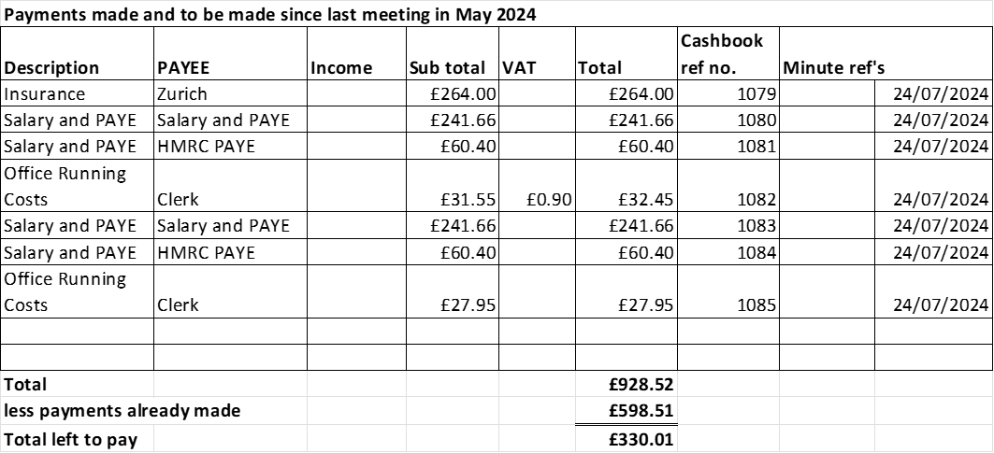  - Budget summary - APPROVED  - Bank reconciliation - APPROVED
13 | To consider matters relating to planning  - 24/39339/HOU Whitehouse Lane Cottage, Whitehouse Lane, Hollywood. Erection of a replacement outbuilding for use as office/workshop/garage.  No objections received
14 | Councillor Information and items for the next Agenda  - Tow path needs cutting back, clerk to contact Canals and Rivers Trust. Cllr Hudson will update any changes.  - Dislodged bridge and erosion on footpath 36. Footpath is still accessible, there is nothing stopping people from using. The willow tree has now rooted, there is an increased flood risk if the bridge and tree stay there. Clerk to send another letter chasing repair, clerk to send draft letter to council for approval before sending.  - RTA w/c 18th July, no fatalities, clerk to add to list.
15 | To agree date of next meeting:  - 3rd September 202 @ Sandon Parish Rooms from 7.30pm  - Extra ordinary meeting - 1st October 2024 - TBC  - 5th November 2024.  - Extra ordinary meeting - 7th January 2025 - TBC  - No meetings in August or December.  Council RESOLVED to change to monthly meetings, temporarily, clerk to plan .
16 | Meeting Closed – 20:44pm

