Sandon and Burston Parish Council
Minutes of the parish council meeting held on Tuesday 7th May 2024 at 7.30pm at
Sandon Parish Rooms, Lichfield Road, Sandon, Staford ST18 0DN
Attendees
Cllr R Wildblood Cllr H Wildblood (Chairman) Cllr G Wyatt
Cllr A Hudson (Vice Chairman) Cllr L Barnett (Joined after co-option)
Cllr A Greaves (Joined after co-option)

Cllr K Aspin – SBC Nikola Evans – Clerk 6 x MOP

1 | Election of Chairman  Proposed – Cllr Wyatt, Second – Cllr Husdon, all in favour of electing Cllr H Wildblood to the position of chairman for 2024-25.  - Newly elected chairman to sign the declaration of office to Chairman. LGA 1972 s83(4)(a) – signed at the meeting in the presence of the proper officer.
2 | Election of Vice Chairman  Proposed – Cllr H Wildblood, Second – Cllr Wyatt, all in favour of electing Cllr Hudson to the position of vice chairman for 2024-25.
3 | Apologies - None
4 | Co-option of three new members to fill vacant seats.  Proposed – Cllr Hudson, Second Cllr Wyatt, all in favour of co-opting Liann Barnett, Adam Greaves and Patrick Hickey to become members of Sandon and Burston Parish Council.  - New members to sign declaration of acceptance of office – LGA 1972 s83 (4)(b) & (c) – Cllr Barnett and Cllr Greaves signed their declaration in the presence of the proper officer. It was RESOLVED to allow Cllr Hickey to sign his declaration before the next meeting.
5 | Minutes of the last meeting – 19th March 2024  Approved a s true record by all that attended.
6 | Declaration of Interests on agenda items  None received
7 | To adjourn the meeting to allow public participation.  It was RESOVED to remove this item, concerns were raised before the meeting in the annual public meeting which took place from 7pm to 7.30pm. Minutes available on the website.
8 | To receive a report from Stafford Borough Councillor and Staffordshire County Councillor  Cllr K Aspin (SBC) advised the following:  - Housing benefits will not be reduced.  - Stafford local plan has been abandoned, for now, due to internal controls not being carried out. This is a concern, if a local plan is not in place, houses can be built anywhere, concerns for communities with no infrastructure.  - 80th D-Day anniversary celebrations @ Victoria Park 6-10pm 6th June 2024  - Grant funding for Village halls – if anyone would like further information, please contact the clerk.  - Accommodation for asylum seekers in Stafford, still ongoing, no further forward.
9 | Planning – None to consider
10 | To discuss and decide on actions for the following issues within the parish.  - A51, specifically from where is changes from 40mph to 60mph just past Sandon Village up to just past Burston Village. – Proposed a list of incidents be kept by the clerk, clerk to arrange a meeting with SCC, highways, and parish council to discuss issues and available options  - Damaged bridge over River Trent from fallen tree.  - Clerk to ask for more details as to why there is no progress and if ROW (SCC) have specific powers to force removal of the tree.  - Inspections should be taking place every 6 week’s, no inspections have been carried out, all the notices are faded and unreadable. Clerk to contact ROW (Rights of Way) copying in, the parish council.  - Footpath 36 erosion – Path is becoming dangerous and unusable for residents, clerk to contact ROW again, and contact contractors to see how much it will cost to put a layer of stones down to even the footpath out.  - Blocked culvert where the stream meets Trent and Mersey Canal then flows off towards the river Trent. – Clerk to carry out some research to see whose responsibility it is to maintain.  - Blocked gully by the triangle in Burston – Concern raised for all the blocked gullies in Sandon and Burston, clerk to do some research and contact contractors to see how much they would charge.  - Triangle in Burston, clean up – Cllr H Wildblood and clerk have contacted Oak Tree Farm, Cllr Wildblood will set up a meeting to discuss what is required and report back.
11 | To review the following policies  - Standing Orders – Reviewed, no changes made – approved.  - Financial Regulations – Reviewed, new template tailored to the parish council, adopted.  - Asset Register – Some items still with a previous chairman, Cllr H Wildblood will collect. – Reviewed and approved.  - Risk Assessment for the Parish council and its functions. (Internal Control) – Added business interruption and cyber security, approved.  - Scheme of delegation – Reviewed and approved, no changes made.
12 | To review arrangements for the parish council becoming eligible to exercise the general power of competence in the future.  The parish council RESOLVED they meet the criteria for GPC, next review date will be at the next relevant meeting in 2027.
13 | Finance – RFO  - Payment approval – reviewed and approved.  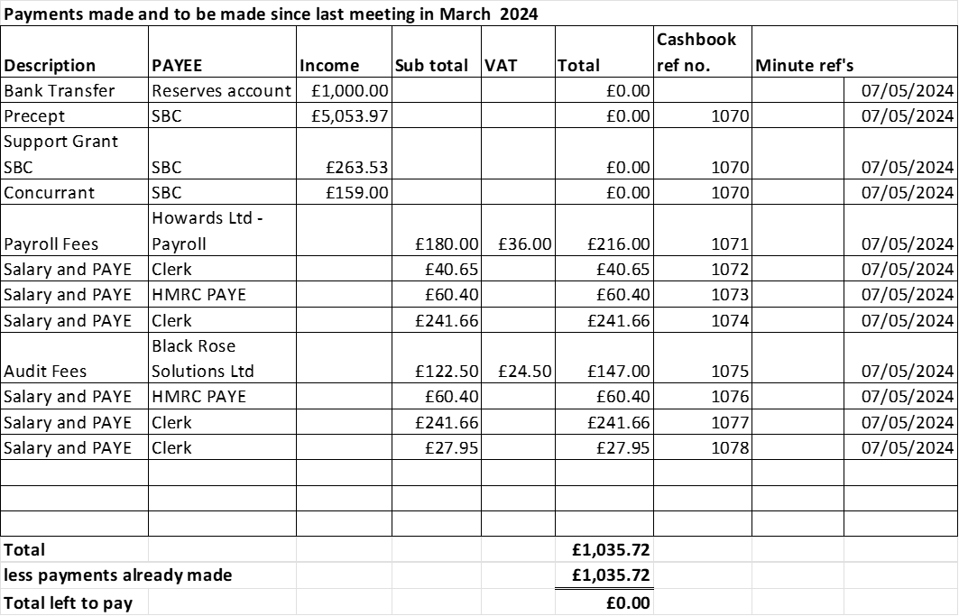  - Budget summary – circulated and approved.  - Bank reconciliation. – circulated and approved  - End of year bank reconciliation for 2023/24 – circulated and approved.  - Circulation and receipt of Internal Audit 2023/24 – circulated and approved.  - Approval of Annual Governance Statement 2023/24 – circulated and approved.  - Approve Accounting Statements 2023/24 – circulated and approved.  - Approve certificate of exemption 2023/24 – circulated and approved.  - To discuss quotes received for parish council insurance 2024/25. – approved to switch to Zurich Municipal @ £264 from Clear Council (formally BHIB) who were quoting £742.75. Clerk has carried out all the necessary checks to make sure the parish council is fully covered.  - To discuss approval and agree for the clerk to request apply for a debit card to pay for subscriptions. – Approved to apply for a debit card.
14 | Councillor Information and items for the next Agenda  - Clerk to send a reminder for agenda items closer to the meeting.
15 | To agree date of next meeting – 2nd July 2024 from 7pm at Sandon Parish Rooms
16 | Meeting Closed – 21.12pm

