Sandon and Burston Parish Council
Minutes of the parish council meeting held on Wednesday 24th January 2024 at 7.00pm at
Sandon Parish Rooms, Lichfield Road, Sandon, Staford ST18 0DN
Attendees
Cllr R Wildblood (Chairman) Cllr H Wildblood Cllr A Hudson Cllr G Wyatt

Cllr K Aspin – SBC Nikola Evans – Clerk 3 x MOP

1 | To receive apologies  Received and accepted by the parish council, Cllr C Capjon and Cllr K Hughes
2 | Minutes of the last meeting – 14th November 2023  Approved as a true record of events by all that attended
3 | To receive any declaration of Interests on agenda items  None received
4 | To adjourn the meeting to allow public participation. (Members of the public are invited to address the council for 15 minutes.)  None
5 | To receive the Borough Councillor’s Report  Cllr K Apsin reported on the following:  - Renovation of Stafford Town centre is ongoing.  - Gateway Station project has received funding and is due to start shortly.  - Garden village at Meece is still under discussions, no further information available.  - Stone Rugby Club and Hockey Club will be merging facilities, £400,000 has been received in funding.  - Parking charges are to increase within Staffordshire, rising by 9%  - There is no further information available for the old university building being used for asylum seekers.  - Brown bin charges to increase to £42 per year.  Checks have been carried out for Staffordshire Police officers and volunteers; no discrepancies have been highlighted.
6 | To receive the County Councillor’s Report  None received

Meeting closed to the public
7 | To receive any reports on Highways issues  The parish council discussed and recognised there was a need to form a working group for speed awareness and other related highways issues. Cllr R Wildblood will take the lead, clerk to advise councillors not able to attend this meeting and produce a flyer asking for volunteers. Flyer will be placed in Compass magazine and noticeboards.  The following issues are ongoing:  - A51, the footpath only goes so far up on one side of the road, forcing pedestrians to cross over a very busy road, to continue along the footpath. Possible solution, pedestrian crossing.  - Concerns for the speed vehicles travel on the A51.
8 | Finance – RFO  - To receive an update from new clerk regarding banking arrangements. – It was resolved to register for online banking and for the RFO to have sole responsibility for making payments by BACS. Two members will sign payment approvals, bank reconciliations and budget summaries at each meeting. RFO will make the necessary arrangements.  - Payment approval – circulated before the meeting and approved at the meeting.  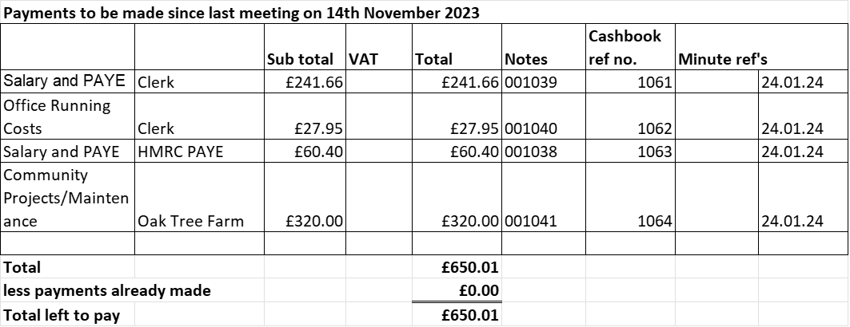  - Budget summary – circulated before the meeting and approved at the meeting.  - Bank reconciliation – circulated before the meeting and approved at the meeting.  - RESOLVED to pay the clerk £14 per month for business use of home.
9 | To consider matters relating to planning  None to be considered.
10 | To discuss and consider current policies.  Clerk reported all the policies are out of date and will need updating. Starting with approving the Risk Assessment and Scheme of delegation at the next meeting before year end.
11 | To receive update on matters arising from previous minutes  - Mobile phone – Clerk advised this is not necessary.  - Zebra crossing on A51 – discussed in item 7.  - Planters – parish council expressed they’re thanks to Cllr G Wyatt, Cllr H Wildblood for organising and Oak Tree Farm for planting. Barrel planters have been installed and planted by Oak Tree Farm. Regarding the rectangle planter, clerk is sure the parish council have paid for this item, clerk to check the records. Still waiting for a location, Cllr G Wyatt will take this forward.  - Tree fall – A briefing has been drafted for Cllr I Parry, clerk to chase for an update.  - Burston pool – Flooding causing footpath 36 to erode, possibly due to debris, clerk to chase Rights of Way team leader for an update and register on ROW system. Members of the public (MOP) have agreed to send pictures and locations plus a list of issues they are experiencing caused by the flooding.  - Burston car park – It was discussed and resolved this car park is for residential parking only. Signs have been placed advising members of the public. No parking access will be granted for other users.  - Styles – Suggested changing two styles over to kissing gates for more accessible access to disabled people. MOP will email locations of styles.  - Buses – Cllr H Wildblood has been in contact with the traffic controller at Stafford County Council (SCC), he is aware of a black hole within the area. Clerk to contact fellow parish clerks, in the area, to ask if they too can make representations to the traffic controller at SCC, requesting this service be investigated for the community.
12 | Councillor Information and items for the next Agenda  - Check contracts for current maintenance providers, consider changing to another company.
13 | To agree date of next meeting – 19th March 2024 from 7pm – TBC  - Future meeting dates : Annual Parish Council Meeting – 7th May 2024, 2nd July 2024, 3rd September 2024 & 5th November 2024. No meetings in August or December.
14 | Meeting Closed – 20:46

